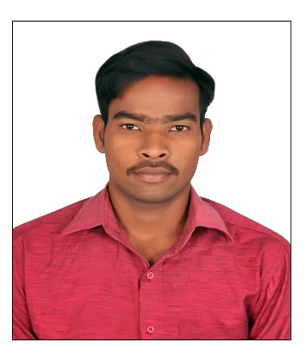

**NAVEEN KUMAR KURMAPU**

Contact: +9

1 9949058991, 8247494347

Email : k.naveen252@gmail.com

**OBJECTIVE**

Seeking a fulltime position in a company that offers challenging job Opportunity.

Where I can improve my abilities and which provides an environment to share knowledge

With other for the success of the organization

**PROFESSIONAL PROFILE**

* **Concierge with 1+ year experience from 5th August 2018 to 26th September 2019 in NTTPS Vijayawada as a Supervisor and Incharge. Highly sociable,**

**Detail-Oriented and Patience.** **Leading people to achieve quality outcomes.**

# **EDUCATIONAL BACKGROUND**

* **Andhra Loyola Institute of Engineering and Technology, Vijayawada.**

Bachelor of Technology in Electrical and Electronic Engineering ( B.TECH in EEE ) with aggregate of 61.63%

Year of pass : 2018

* **Govt.Polytechnic college Vijayawada.**

Diploma in ELECTRICAL and ELECTRONICS ENGINEERING with an aggregate of 80%

Year of pass : 2015

* **Brilliants Convent and High School**

SSC with a GPA of 8.5

Year of pass : 2012

**KEY SKILLS**

* Leadership
* Teamwork
* Problem solving
* Analytical skills
* Adaptability to change
* Communicational skills

* Time Management
* Project Management skills
* Strategic thinking &
* Planning abilities

**EXPERIENCE**

Having 1+year experience from 5th August 2018 to 26th September 2019 as a Supervisor and Incharge in MYNALA POWER SYSTEMS PRIVATE LIMITED at site location NTTPS Vijayawada.

**EXTRA-CIRCULAR ACTIVITIES**

* Organized an Event on ENGINEERS DAY in our College.
* Participated in Dibet on FUTURE OF INDIA in AmruthSai College of Engineering.

**COMPUTER KNOWLEDGE**

* Ms-office ( Word, Excel, Power point )
* Computer hardwaring.
* JAVA, ORACLE, HTML, CSS

**HOBBIES**

* Playing VOLLYBALL , CRICKET, CHESS .
* Watching NEWS.

**PERSONAL INFORMATION**

* Date of Birth : 25th April 1997
* Marital Status. : Single
* Nationality : Indian
* Languages known : English, Hindi, Telugu.
* Address : 3-52,opt Andhra bank, Mee Seva road,

Ibrahimpatnam, Krishna distic, AP-521456

**DECLARATION**

I hereby declare that the above mentioned details are true to best of my knowledge

NAVEEN KUMAR KURMAPU